SYSTEMS ENGINEERING PROJECT:

INDUSTRIAL

ROBOTIC ARM

**Team:**

Ciobanu Bianca Nicola

Lupașcu Gelu-Codrin

Nicoară Andreea-Georgeta

Stanciu Ștefan-Daniel

**Group 1242B**

The problem of developing a robotic arm is to create a mechanical device that can mimic the actions of a human arm and hand, allowing it to manipulate objects in a specific environment. The robotic arm must be able to perform these actions accurately and efficiently, while also being robust and reliable.

The scope of the project will depend on the specific requirements of the application, but generally, it will include the following tasks:

**Research:** Researching existing robotic arm technologies and determining the best approach for the specific application. This may include studying the mechanics of human arm movement, as well as reviewing existing robotic arm designs and technologies.

**Design and development:** Designing and developing the mechanical and electrical components of the robotic arm. This may include creating detailed CAD models, as well as building and testing prototypes.

**Control systems:** Programming the control systems for the robotic arm, which will enable it to move and manipulate objects as desired. This may include developing algorithms for motion planning and control, as well as integrating sensors and other feedback systems.

**Testing and validation:** Thoroughly testing and validating the robotic arm to ensure that it meets the desired performance criteria. This may include conducting simulations, as well as testing the arm in a real-world environment.

**Integration:** Integrating the robotic arm with other systems, such as sensors, cameras, or a user interface. This may include developing software to communicate between the different systems, as well as designing and building any necessary hardware interfaces.

**Deployment:** Deploying the robotic arm in the intended application, which may include installing the arm in a factory or research lab, as well as providing training and support to users.

**Maintenance:** Maintaining and upgrading the robotic arm over time, which may include replacing worn or broken components, as well as updating software and control systems as needed.

Overall, developing a robotic arm project is a complex task that involves multiple disciplines such as mechanical engineering, electrical engineering, computer science, and control theory. The scope of the project will depend on the specific application, but it generally includes tasks such as researching existing technologies, designing and developing the mechanical and electrical components, programming control systems, testing and validating the arm, integrating it with other systems, deploying it in the intended application, and maintaining and upgrading it over time.

**There are several current approaches to solving the problem of developing a robotic arm, each with their own advantages and drawbacks:**

Serial-link robotic arms: Serial-link robotic arms are the most common type of robotic arm and consist of a series of interconnected links and joints, similar to the bones and joints of a human arm. They are highly versatile and can be used in a wide range of applications, such as manufacturing, assembly, packaging, welding, and many more.

Serial-link robotic arms are composed of several segments, called links, that are connected by joints. The joints allow the links to rotate and move with respect to each other, allowing the robotic arm to reach different positions and orientations. The links and joints are typically driven by electric motors or pneumatic cylinders, which provide the power to move the arm.

One of the main advantages of serial-link robotic arms is their versatility. They can be designed to reach a wide range of positions and orientations and can be used for a wide range of tasks, such as welding, painting, or assembling objects. They can also be designed to handle a wide range of payloads, from small, delicate objects to large, heavy ones.

However, serial-link robotic arms can be complex to design and control, requiring a high level of expertise in mechanical and electrical engineering, as well as control systems. The control system is responsible for coordinating the movement of the different joints, ensuring that the robotic arm moves in the desired way. This requires precise control of the motors or actuators that drive the joints, as well as the use of algorithms for motion planning, trajectory generation, and control.

Another drawback of serial-link robotic arms is that they can be limited in terms of speed and payload capacity, particularly when trying to handle heavy or large objects. They are also sensitive to the environment, and their accuracy can be affected by factors such as temperature, humidity, or vibration.

In summary, serial-link robotic arms are versatile and widely used in industry due to their range of motion and ability to handle different payloads. They can be complex to design and control, but with the right expertise and technologies, they can be a valuable tool for a wide range of applications.

**Second Approach Parallel-link robotic arms:**

Parallel-link robotic arms, also known as parallel robots or parallel kinematic machines, are a type of robotic arm that use parallel links and actuators, rather than serial links and joints. The main advantage of parallel-link robotic arms is their compact design, which allows for a smaller footprint and higher payload capacity than serial-link robotic arms. They also have a higher degree of stiffness and accuracy, which can make them more efficient and precise than serial-link robotic arms.

The design of parallel-link robotic arms typically consists of a fixed base and a moving platform, which is connected to the base via multiple parallel links. The links are actuated by motors, which control the movement of the platform. The number of links and degrees of freedom can vary depending on the design, but typically parallel-link robotic arms have at least 3-6 degrees of freedom.

One of the most common types of parallel-link robotic arm is the Stewart platform, which uses six parallel links to connect the base and moving platform. This design provides high stiffness and accuracy, making it well suited for precision tasks such as assembly and manipulation of small parts. Another type of parallel-link robotic arm is the Delta robot, which uses three parallel links to connect the base and moving platform. This design is well suited for fast and precise tasks such as packaging and pick-and-place operations.

One of the main challenges of parallel-link robotic arms is their control. The control of parallel-link robotic arms requires a high level of expertise in control systems and inverse kinematics, as the movements of the platform are not directly related to the movements of the actuators. Additionally, parallel-link robotic arms can be sensitive to changes in their environment, such as changes in temperature or mechanical wear, which can affect their performance.

In terms of applications, parallel-link robotic arms are well suited for precision tasks, such as assembly and manipulation of small parts, as well as for fast and precise tasks such as packaging and pick-and-place operations. They also have been used in research fields such as medical and surgical robots, as well as in micro-manipulation tasks in the semiconductor industry.

Overall, parallel-link robotic arms offer a number of advantages over serial-link robotic arms, such as higher stiffness and accuracy, as well as a smaller footprint. However, their control can be challenging, and they may not be as versatile in terms of the range of applications they can be used for.

The choice between parallel-link and serial-link robotic arms depends on the specific requirements of the application. Both types of arms have their own advantages and disadvantages, and the best choice will depend on factors such as payload capacity, speed, precision, and versatility.

Serial-link robotic arms:

Pros:

* High versatility: Serial-link robotic arms can be used in a wide range of applications, such as manufacturing, assembly, and packaging.
* Well-established technology: Serial-link robotic arms have been used for many years and are well understood, making them relatively easy to design and control.

Cons:

* Complexity: Serial-link robotic arms can be complex to design and control, requiring a high level of expertise in mechanical and electrical engineering, as well as control systems.
* Payload capacity and speed: Serial-link robotic arms may be limited in terms of payload capacity and speed, particularly when trying to handle heavy or large objects.

Parallel-link robotic arms:

Pros:

* Compact design: Parallel-link robotic arms have a more compact design than serial-link robotic arms, which allows for a smaller footprint and higher payload capacity.
* High stiffness and accuracy: Parallel-link robotic arms typically have a higher degree of stiffness and accuracy than serial-link robotic arms, which can make them more efficient and precise.

Cons:

* Control: The control of parallel-link robotic arms can be challenging, requiring a high level of expertise in control systems and inverse kinematics.
* Versatility: Parallel-link robotic arms may not be as versatile in terms of the range of applications they can be used for, compared to serial-link robotic arms.

In terms of which arm to choose, it would depend on the specific requirements of the application and the trade-offs that are acceptable. Given that our application requires a high degree of versatility, a serial-link robotic arm would be the better choice. On the other hand, if the application requires a high degree of precision and speed, parallel-link robotic arm would be a good choice.

It is important to note that, as the technology is constantly evolving, new developments in areas such as materials, sensors, and control systems can help to improve the performance and capabilities of both types of robotic arms. Additionally, hybrid robotic arms, that combine elements of both serial-link and parallel-link designs, can also be a viable option for certain tasks that require a combination of speed, precision, and versatility.

In terms of available technologies, there are several that are commonly used in robotic arm development, such as:

Actuators: These are the devices that provide the power to move the robotic arm, and can include electric motors, pneumatic cylinders, and hydraulic actuators.

Sensors: These devices provide feedback on the position and movement of the robotic arm, and can include encoders, accelerometers, and force sensors.

Control systems: These are the algorithms and software that control the movement of the robotic arm, and can include motion planning, trajectory generation, and control algorithms.

Computer vision: This technology allows the robotic arm to perceive and understand its environment, which can be used for tasks such as object recognition and grasping.

Artificial intelligence and Machine learning: These technologies can be used to improve the performance of the robotic arm and make it more adaptable to new tasks.

Materials: Advanced materials such as carbon fiber, lightweight metals, and composite materials, can be used to make the robotic arm lighter and more durable.

Overall, each approach has its own advantages and drawbacks, and the choice of approach will depend on the specific requirements of the application. Furthermore, the available technologies are constantly evolving, and new developments in areas such as materials, sensors, and control systems can help to improve the performance and capabilities of robotic arms.

**Stakeholders**

**Manufacturer or developer:** The robotic arm's successful development and commercialization will be in the manufacturer's or developer's best interests. They will require a cost-effective design and development process, as well as a high level of performance and reliability from the arm. To ensure that the arm can be effectively offered to clients, this will necessitate the employment of cutting-edge technology, materials, and components together with a strong business plan and marketing strategy. The manufacturer must also make sure that the arm complies with all applicable laws and standards and that it can be maintained effectively through effective after-sales service.

**End-users:** The people or businesses who will employ the robotic arm in their operations are known as end-users. The arm must be simple to operate, have an intuitive interface, and be highly accurate and effective while carrying out the particular duties for which it was created. This covers the requirement for easy system integration, thorough documentation, and end-user training. Additionally, the arm must be dependable, sturdy, and simple to maintain for end users.

**Customers:** Individuals or organizations who will purchase the robotic arm from the manufacturer are referred to as customers. They will require the arm to meet their specific needs as well as perform the tasks for which it was designed. This includes the requirement for the arm to be customized to their specific requirements and to integrate with their existing systems. Customers will also expect the arm to be well-supported after the sale and to have an effective maintenance system.

**Regulators:** The government agencies or other organizations in charge of regulating the usage of robotic arms in particular fields or settings are known as regulators. They will need that the arm be developed and designed in accordance with pertinent laws and standards, and that it be secure for use in the specified setting. In order to make sure the arm complies with all pertinent safety and performance criteria, the manufacturer will need to cooperate closely with regulators.

**Investors:** Financial support for the creation of the robotic arm has been given by individuals or groups. They will require the arm to be created and commercialized quickly, affordably, and with a high likelihood of profit. This calls for the manufacturer to have a strong marketing strategy and business plan, as well as a thorough understanding of the target market and the potential for profit. Investors will also require regular updates on the project's status and their investment's return.

**Suppliers:** Suppliers are the individuals or organizations that provide components, materials, or services to the manufacturer. They will need the arm to be designed and developed with materials and components that are readily available and at a reasonable cost. This includes the need for the manufacturer to have a good relationship with suppliers, and to ensure that the materials and components used in the arm are of high quality and meet relevant regulations and standards. Additionally, suppliers will need to be able to deliver the materials and components in a timely and cost-effective manner.

**Researchers and Scientists**: Researchers and Scientists are persons or organizations active in the robotic arm's research and development. They will require that the arm be created and built using the most recent scientific breakthroughs and technology, and that it be capable of doing the jobs for which it was designed with great accuracy and efficiency. This includes the manufacturer's requirement to collaborate closely with researchers and scientists to guarantee that the arm integrates the most recent advancements in robotics, materials, and control systems. Researchers and scientists will also require access to the arm for testing and experimentation.

**System Requirements**

Operational requirements: These are the requirements that define how the arm is intended to be used. Examples of operational requirements include:

* The specific tasks that the arm is expected to perform (e.g. assembly, manipulation, pick-and-place, etc.)
* The range of motion required, including the number of degrees of freedom, reach, and payload capacity.
* The precision and accuracy needed, including the repeatability and resolution of the arm's movement.
* The speed of operation, including the maximum and minimum speeds at which the arm can move.
* The ability to operate in specific environments, such as extreme temperatures, hazardous locations, or underwater.
* The ability to interface with other systems, such as sensors or cameras, to provide additional functionality.
* The ability to perform specific tasks, such as grasping or cutting.

Physical requirements: These are the requirements that define the physical characteristics of the arm. Examples of physical requirements include:

* The size, weight, and shape of the arm, including the footprint and height.
* The materials and components used to construct the arm, including the choice of actuators, links, and joints.
* The ability to withstand specific loads or forces, such as heavy payloads or high-impact forces.
* The ability to operate in specific environments, such as extreme temperatures, hazardous locations, or underwater.
* The ability to interface with other systems, such as sensors or cameras, to provide additional functionality.
* The ability to perform specific tasks, such as grasping or cutting.

Safety and security requirements: These are the requirements that ensure the arm is safe for use and that it is protected against unauthorized access or use. Examples of safety and security requirements include:

* The need for the arm to be able to detect and avoid obstacles, using sensors or cameras.
* The need for the arm to have emergency stop and shut-off mechanisms, in case of an emergency or malfunction.
* The need for the arm to be protected against hacking or other cyber-security threats, using encryption or other security measures.
* The need for the arm to be compliant with relevant safety regulations and standards.
* The need for the arm to have a protective housing or enclosure to protect the operators and the environment from any dangerous elements.

Environmental requirements: These are the requirements that define the conditions under which the arm will be operated. Examples of environmental requirements include:

* The need for the arm to be able to operate in specific temperatures, humidity levels, or lighting conditions.
* The need for the arm to be able to withstand specific types of exposure, such as vibration or radiation.
* The need for the arm to be able to operate in extreme temperatures, and meet specific IP ratings.

Power and energy requirements: These are the requirements that define the power and energy needs of the arm. Examples of power and energy requirements include:

* The need for the arm to be able to operate for a specific amount of time on a single charge or battery.
* The need for the arm to be able to operate using specific types of power sources, such as solar or wind power.
* The need for the arm to have an efficient energy management system to optimize the power usage.
* The need for the arm to have a redundant power supply system to ensure continuous operation even in case of power failure.

Human-robot interaction requirements: These are the requirements that define how the arm is intended to interact with humans. Examples of HRI requirements include:

* The ability to respond to voice commands, gestures, or other inputs, using natural language processing or computer vision techniques.
* The ability to provide visual or auditory feedback to the operator, using displays or speakers.
* The ability to recognize and adapt to different users, using identification or biometric techniques.
* The need for the arm to have an intuitive and user-friendly interface for easy operation.
* The need for the arm to have an efficient and safe emergency stop mechanisms.

Integration requirements: These are the requirements that define how the arm is intended to be integrated with other systems, such as sensors, cameras, or control systems. Examples of integration requirements include:

* The ability to share data with other systems, using communication protocols such as Ethernet or Wi-Fi.
* The ability to be controlled remotely, using a PC or mobile device.
* The ability to be integrated with other systems, such as conveyors, or other robotic systems, to provide additional functionality.
* The need for the arm to be able to integrate with existing systems, such as PLCs, or SCADA systems.

Maintenance and support requirements: These are the requirements that define the arm's maintenance and support needs. Examples of maintenance and support requirements include:

* The need for the arm to have a user-friendly interface for easy maintenance.
* The need for the arm to have easy access to spare parts.
* The need for the arm to have an efficient and reliable maintenance system, that can be performed on-site or remotely.
* The need for the arm to be supported with good after-sales service, technical support and training for end-users.
* The need for the arm to have good documentation, including user manuals and troubleshooting guides, to ensure that end-users can easily maintain and operate the arm.

**Planned Approach**

System Engineering methods and tools are commonly used in the development of robotic arms. Some examples include:

* Work Breakdown Structure (WBS): This is a hierarchical method of dividing a project into smaller, more manageable tasks. This can help to ensure that all aspects of the project are covered, and that resources are allocated effectively.
* Gantt chart: This is a tool used to create a visual representation of the project schedule, showing the start and end dates of each task, as well as any dependencies between tasks. This can help to ensure that the project stays on schedule, and that resources are allocated effectively.
* Modeling tools: These tools can be used to create visual representations of the arm and its components, as well as to simulate its performance and behavior. Examples of modeling tools include SolidWorks, CATIA, and Pro/Engineer.
* Systems Modeling Language (SysML): This is a modeling language that can be used to create visual representations of the arm and its components, as well as to simulate its performance and behavior. SysML diagrams can be used to represent the different components of the arm, as well as the interactions between those components.

In terms of the different concepts generated, it will depend on the specific project. However, some examples of concepts that might be generated during the planning phase include:

* The mechanical design of the arm, including the number and type of links and joints, as well as the materials and components used.
* The control system for the arm, including the algorithms and software used to control the movement of the arm.
* The end-effectors or grippers used to grasp and manipulate objects.
* The power and energy systems used to operate the arm.
* The safety and security systems used to protect the arm and its operators.
* The human-robot interaction (HRI) systems used to allow the arm to interact with humans in a natural and intuitive way.
* The integration of the arm with other systems, such as sensors and cameras, to provide additional functionality.

There are several challenges and issues that may arise during the development of a robotic arm project, such as:

**Technical challenges:** Designing and building a robotic arm that can accurately and efficiently manipulate objects can be a complex task, requiring a high level of expertise in mechanical and electrical engineering, as well as control systems.

**Integration challenges:** Integrating the robotic arm with other systems, such as sensors or a user interface, can be challenging, and may require additional time and resources to ensure that everything works together seamlessly.

**Testing and validation:** Thoroughly testing and validating the robotic arm to ensure that it meets the desired performance criteria can be time-consuming and may require additional resources, such as specialized equipment or facilities.

Cost: Robotic arm projects can be expensive to develop and maintain, and costs can quickly escalate if unexpected issues arise during the development process.

**Risk of component failure:** Due to the mechanical and electrical components involved in the robotic arm system, there is a risk of component failure. This may cause the arm to malfunction and may cause a downtime, which can be costly and can cause delays in the project.

**Safety and security risks:** Robotic arms can pose safety and security risks, especially when they are used in environments where they may encounter humans. Careful planning and design is needed to mitigate these risks.

**Risk of obsolescence:** Robotics technology is evolving rapidly and there is a risk that the technology used in the arm will quickly become obsolete, making the arm difficult to maintain and upgrade.

**Challenges**

**Quality Assurance Plan**

There is no lack of templates for SQA plans, but there is no "one-size-fits-all" template. Effective plans must be tailored to the specific project and as carefully designed as any part of the system. In order to progress from a generalized template to a more focused plan[1], the following possible quality goals for the LDUA software were examined:

• comprehensiveness

• efficiency

• expendability

• flexibility

• integrity

• interoperability

• maintainability

• portability

• reliability

• responsiveness

• reusability

• survivability

• testability

• usability.

The primary SQA goals of the software to be used with the LDUA were reliability, usability, and maintainability. Reliability was important because significant operating costs and potential radiation exposure to workers could be the consequence of frequent system breakdowns. Maintainability was important because WHC would ultimately be responsible for repairing and improving the software of which much was custom that would not be supported by its supplier after delivery to WHC. Usability was important because the LDUA is to be operated by operations personnel rather than engineers and scientists.

**Reliability:** This is a measure of how dependable a product or system is, or how often it fails to perform its intended function. Examples of reliability metrics include Mean Time Between Failures (MTBF) and Failure Rate. For example, a robotic arm with a high MTBF would be considered more reliable than one with a low MTBF, as it would require less maintenance and downtime.

**Usability:** This is a measure of how easy a product or system is to use. Examples of usability metrics include Time to Complete a Task, Error Rate, and User Satisfaction. For example, a robotic arm that is easy to operate and has a user-friendly interface would be considered more usable than one that is difficult to operate or has a confusing interface.

**Maintainability:** This is a measure of how easy a product or system is to maintain, or how often it requires maintenance. Examples of maintainability metrics include Mean Time to Repair (MTTR) and Maintenance Cost. For example, a robotic arm that is easy to maintain and has a low MTTR would be considered more maintainable than one that is difficult to maintain or has a high MTTR.

**Connclusion**

**TBD**

References:

[1]. G. R. Kiebel, An Approach to Software Quality Assurance for Robotic Inspection Systems, American Nuclear Society 1993 Winter Meeling San Francisco, California November 14-19, 1993, Published October 1993 Westinghouse Hanford Company

Annexes:

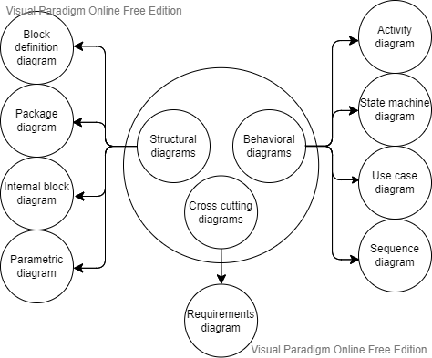

*Annex 1: SysML Diagram*

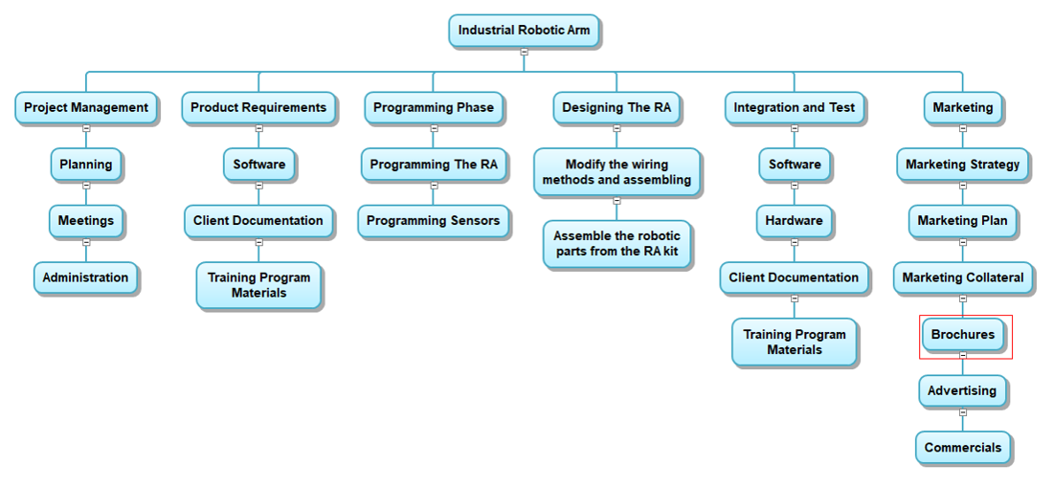

*Annex 2: WBS Diagram*

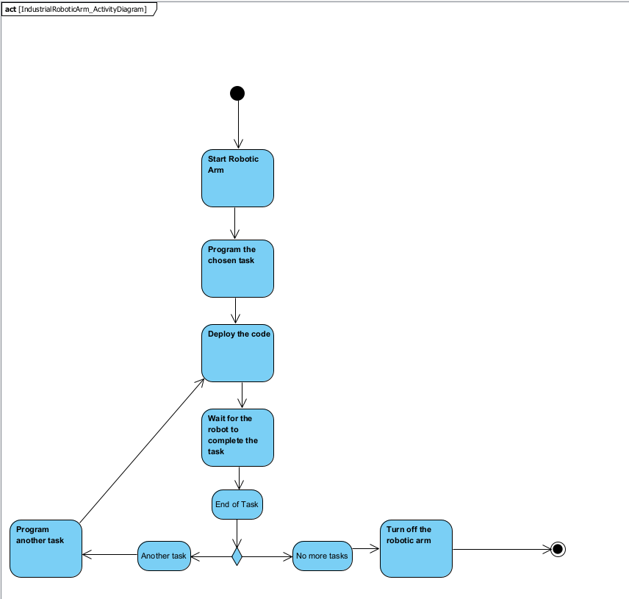

*Annex 3: Activity Diagram*

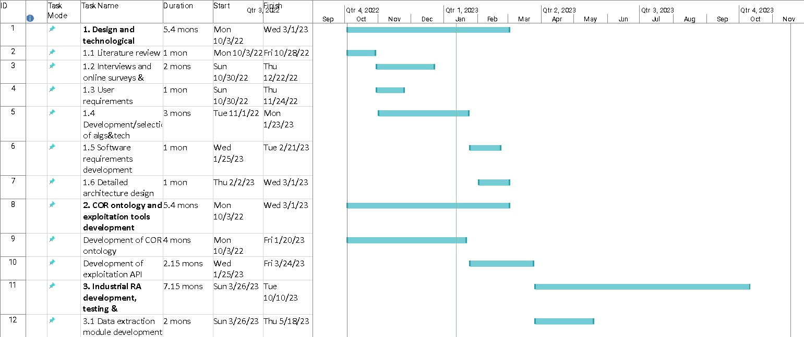

*Annex 4: GanttChart Page1*

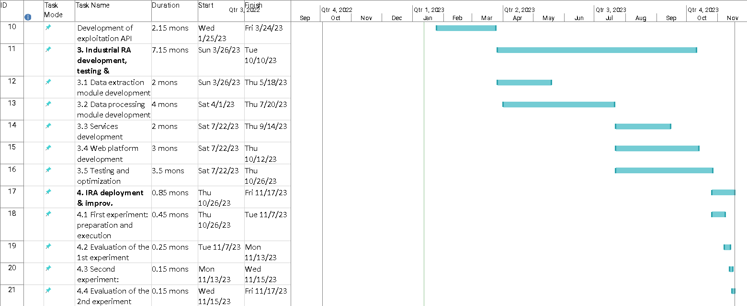

*Annex 5: GanttChart Page2*

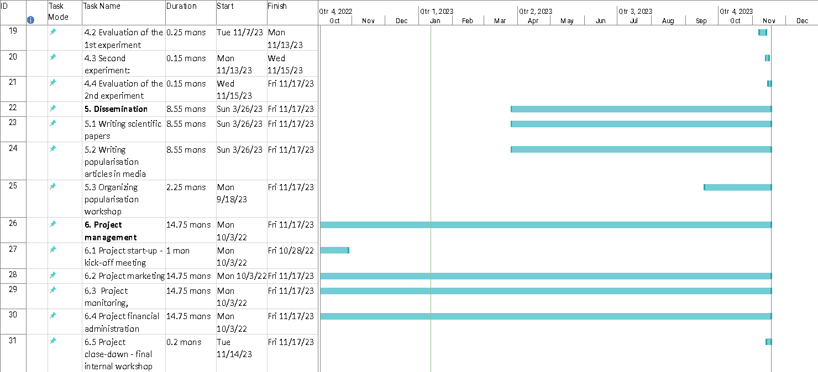

*Annex 6: GanttChart Page3*

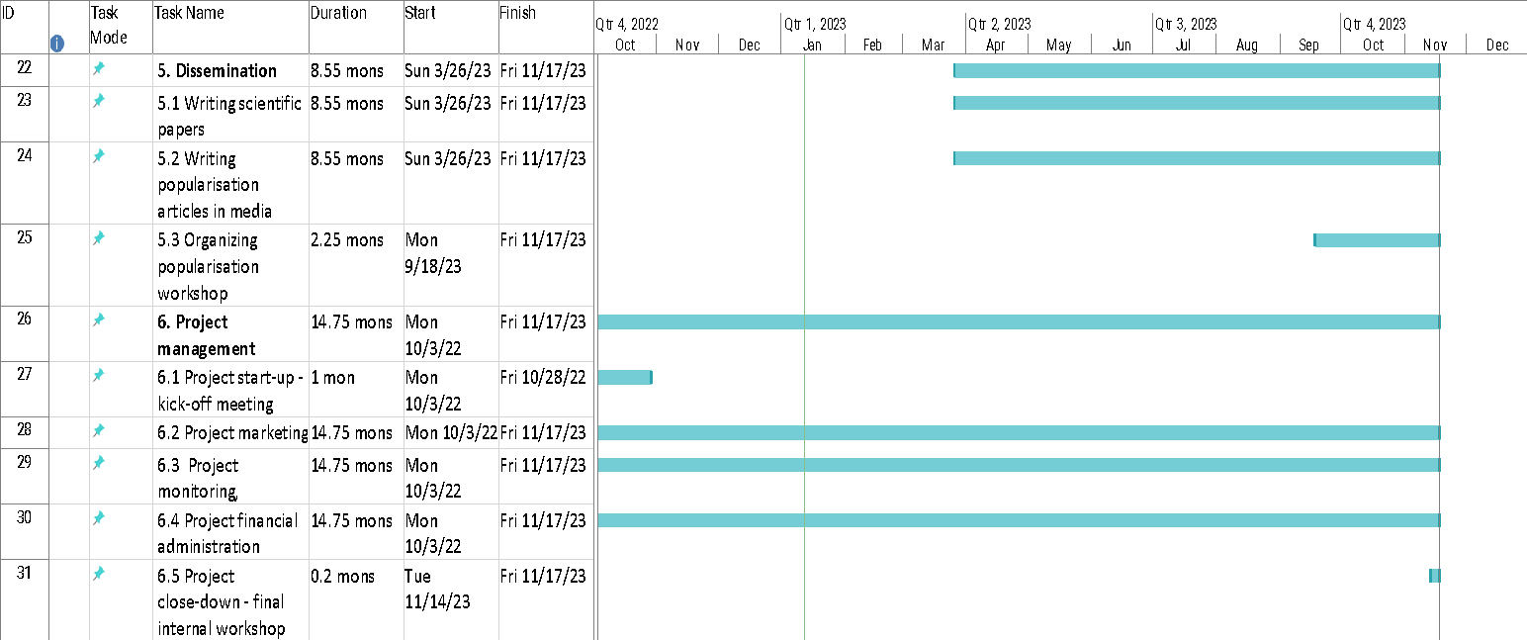

*Annex 7: GanttChart Page4*

*Annex 8: IRA_UseCaseDiagram*